MDM TA3
Library Management System: Flask, SQLite and REST
Name | Ambuj Tripathi
Roll No. | 05
Section | B
Department | ENCS

1. Project Overview
This project is a web-based Library Management System built as a Technical Assignment (Aim 4). It gives a librarian a single desk-style interface to manage the book catalogue, register library members, issue books, accept returns and review the full history of transactions. The application is written in Python with the Flask framework, stores its data in a SQLite database, and exposes its functionality through REST endpoints that the browser front end calls using fetch().
The front end is served by Flask itself, so the page and the API share the same origin (http://127.0.0.1:5000). This avoids cross-origin configuration and keeps the whole project runnable with a single command: python app.py.

1.1 Technology Stack
Layer | Technology
Back end | Python with the Flask web framework (app.py)
Database | SQLite (library.db), with the table definitions in schema.sql and connection helpers in database.py
API style | REST endpoints returning data to the browser via fetch() calls
Front end | HTML, CSS and JavaScript single-page interface (frontend folder, index.html)
Validation | Server-side input checks in validators.py (for example phone numbers of 7 to 15 digits)
Testing | API test script (test_api.py)
Editor / environment | Visual Studio Code with a Python virtual environment (venv)

1.2 Main Features
- Dashboard: live counts of titles, copies, issued books and members, a shelf-status bar, recently added books, recent issues and returns, and a warning banner for overdue books.
- Book management: a catalogue with title, author, ISBN, category, copies available and status, plus add, edit and delete actions.
- Search and filter: search by title, author, ISBN or category, and filters by category and availability.
- Member management: register members with name, email and phone number, with edit and delete actions and a search box.
- Issue and return: choose a member and a book (only books with at least one available copy are listed), set the issue and due dates, and return books from the currently-issued list.
- Transactions: a complete log filtered into All, Active issues and Returned, with Issued, Overdue and Returned status labels.

2. Implementation
The project folder (library-management-system) contains the Flask application, the database layer and the front end. The structure visible in the editor is:
File / Folder | Purpose
app.py | Main Flask application: routes, search logic and the API endpoints
database.py | Database connection and initialisation helpers
schema.sql | SQL definition of the tables (books, members, transactions)
library.db | The SQLite database file
validators.py | Validation of user input before it is saved
test_api.py | Tests for the API
frontend/ | index.html and the front-end assets served by Flask
docs/ | Project documentation
requirements.txt, README.md | Dependencies and setup instructions

The home route ("/") returns the front end using send_from_directory, so opening the server address loads the interface. The search_books function builds its SQL query dynamically: it starts from SELECT * FROM books WHERE 1 = 1 and appends conditions for the search text, category and availability only when those filters are supplied. Search text is turned into a LIKE pattern, and a second pattern with hyphens removed lets an ISBN be found whether or not it is typed with hyphens. The query values are passed as parameters rather than joined into the string. The transactions query joins the transactions table with books and members to show titles and member names in the history.
Figure 1 shows the project in Visual Studio Code, with app.py open and the server started in the terminal. The terminal confirms the application is running at http://127.0.0.1:5000 and that the home page request returned status 200.
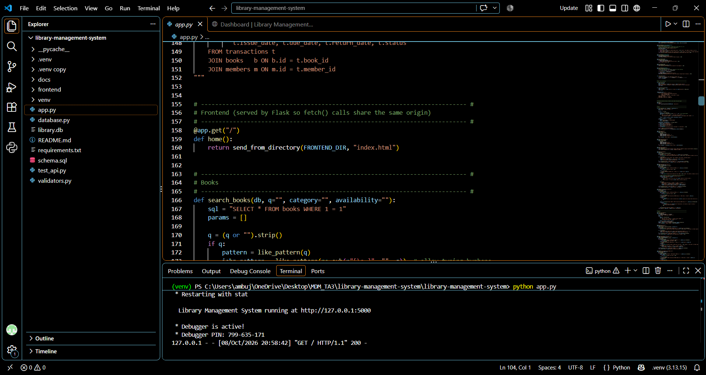
Figure 1: Project structure, app.py source code and the Flask server running in the VS Code terminal.

3. Output Screenshots

3.1 Dashboard
The dashboard is the landing page. It summarises the library at a glance: 16 book titles with 47 copies in total, 43 copies on the shelf, 4 books currently issued (2 of them overdue) and 7 registered members. A yellow banner warns that 2 books are past their due date and links to the issued-books list. Below it, the shelf-status bar shows 43 of 47 copies on the shelf, and two panels list the recently added books and the recent issues and returns with their status.
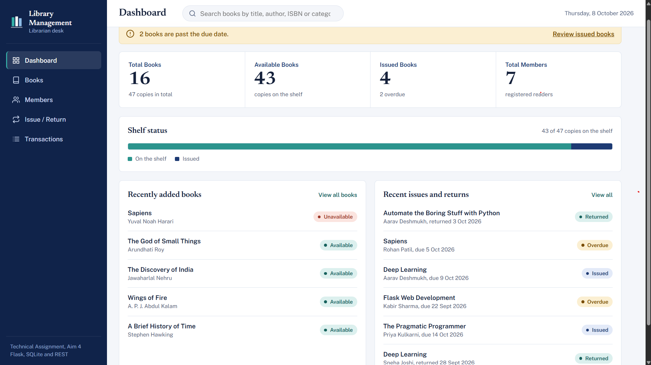
Figure 2: Dashboard showing library statistics, shelf status, recently added books and recent issues and returns.

3.2 Books Catalogue
The Books page lists the whole catalogue (16 books). Each row shows the book ID, title and author, ISBN, category, copies available out of total copies, and a status label, along with Issue, Edit and Delete actions. An Add book button opens the form for adding new titles.
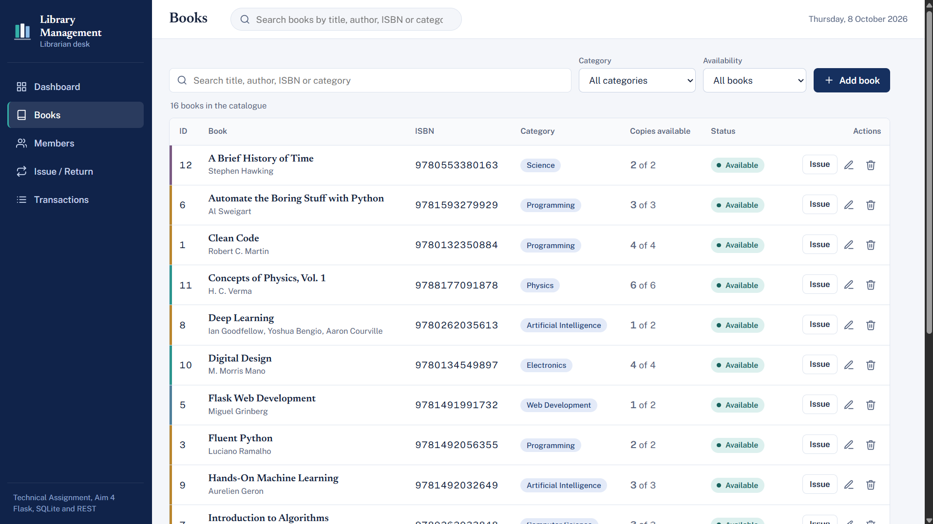
Figure 3: Books page listing the catalogue with ISBN, category, copies available and status.

3.3 Filtering by Category
The Category drop-down filters the catalogue. The categories available in the library are Artificial Intelligence, Biography, Computer Science, Electronics, Fiction, History, Physics, Programming, Science and Web Development.
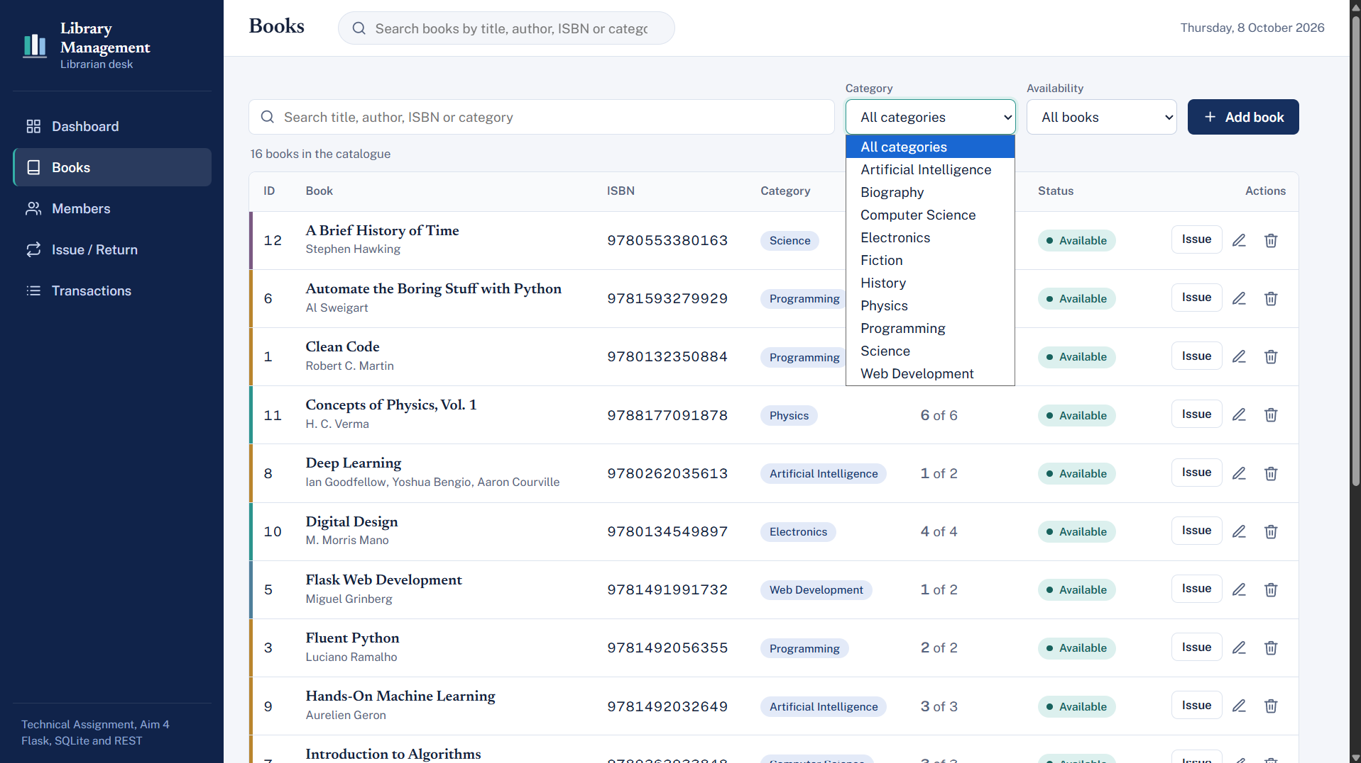
Figure 4: Category filter drop-down listing all book categories.

3.4 Searching and Availability Filter
Typing in the search box narrows the catalogue as the user searches. Here the search for "Deep Learning" returns 1 book found: Deep Learning by Ian Goodfellow, Yoshua Bengio and Aaron Courville, with 1 of 2 copies available. The Availability drop-down offers All books, Available and Unavailable.
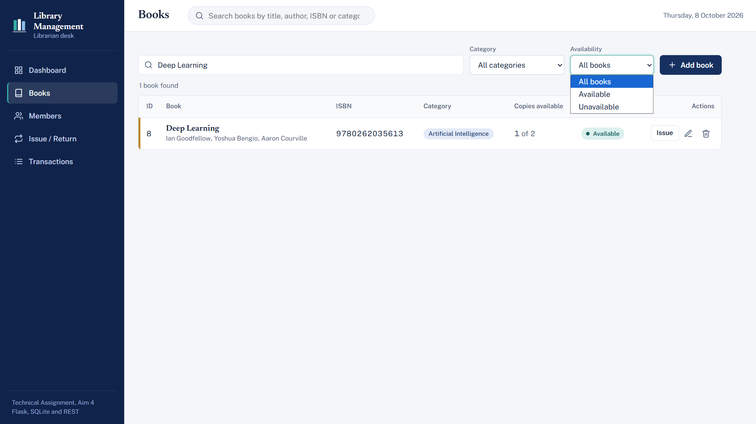
Figure 5: Searching for "Deep Learning" and the Availability filter options.

3.5 Member Management
The Members page shows each member's ID, name, email, phone number and registration date, and a search box that accepts a name, email or member ID. Clicking Add member opens a form with Full name, Email and Phone number fields. A hint under the phone field states that 7 to 15 digits are accepted and that +91, spaces or hyphens may be included.
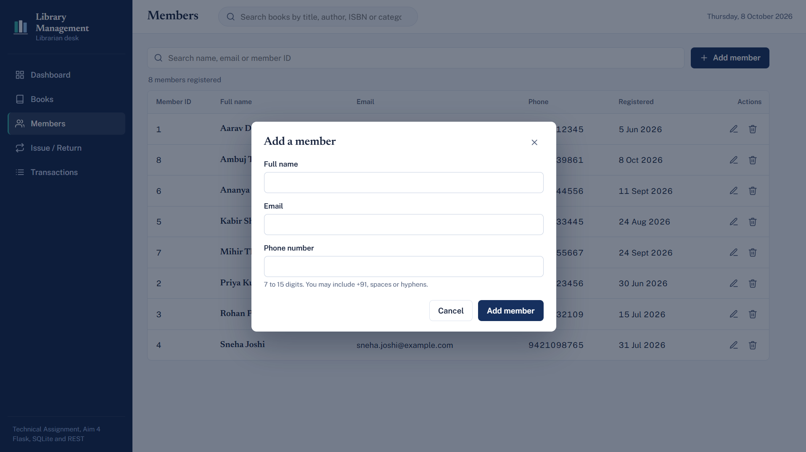
Figure 6: Add a member form with Full name, Email and Phone number fields.
After the form is submitted, the new member appears in the list (member ID 8, registered 8 Oct 2026) and a confirmation message in the bottom-right corner reports that the member was registered. The page header now reads 8 members registered.
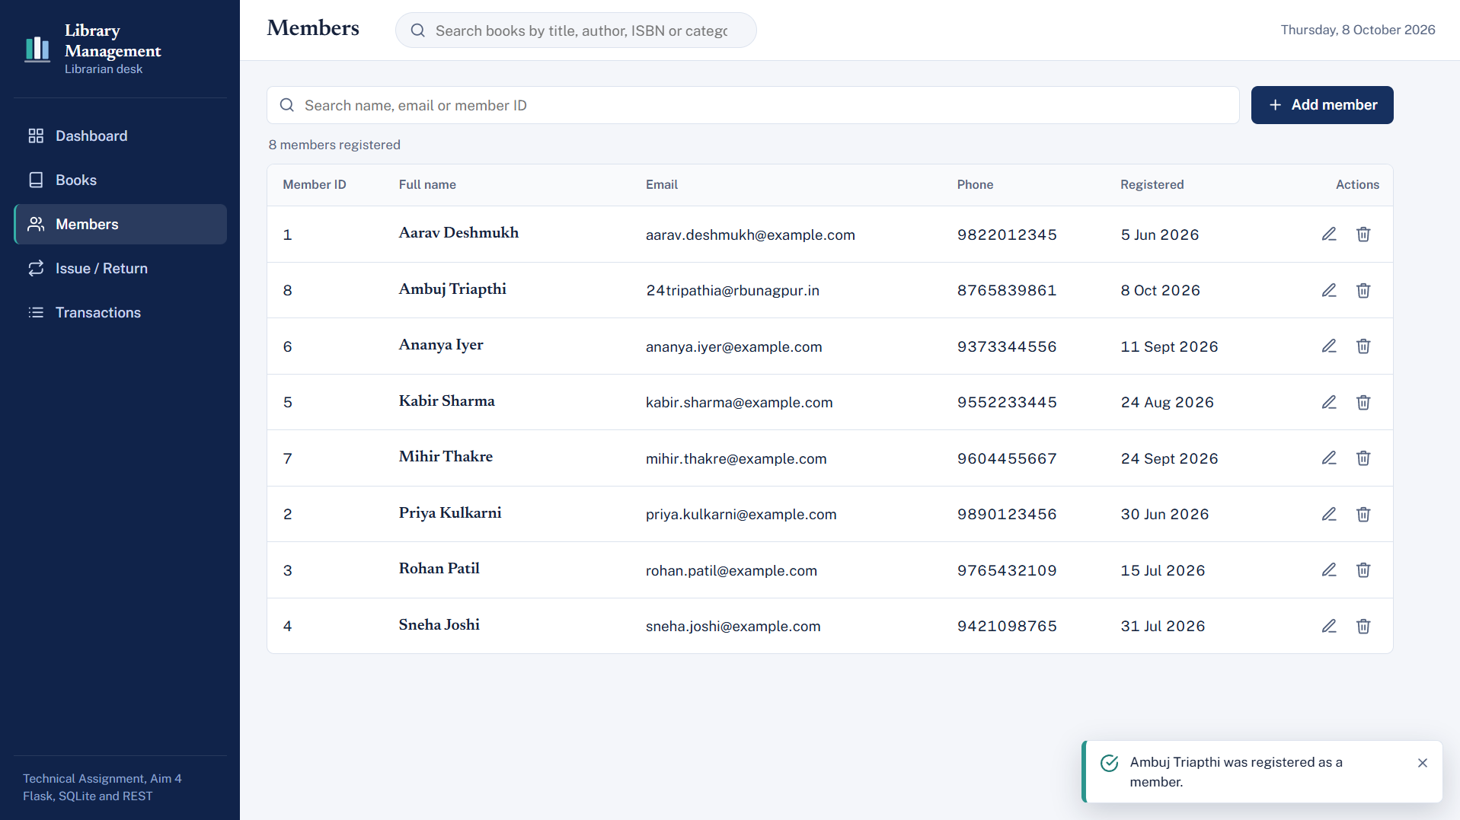
Figure 7: Members list after registering a new member, with the success notification.

3.6 Issuing a Book
The Issue / Return page has an Issue a book panel on the left and a Currently issued table on the right. The first step is to choose the member from a drop-down that lists every registered member with their ID.
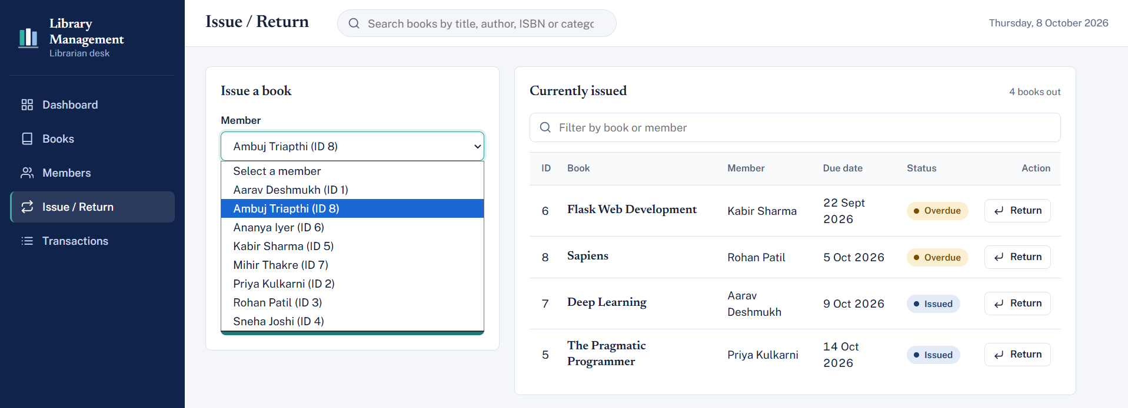
Figure 8: Issue / Return page: selecting the member from the drop-down list.
The second step is to choose the book. Only books with at least one available copy are listed, and each entry shows the author and the number of copies still available.
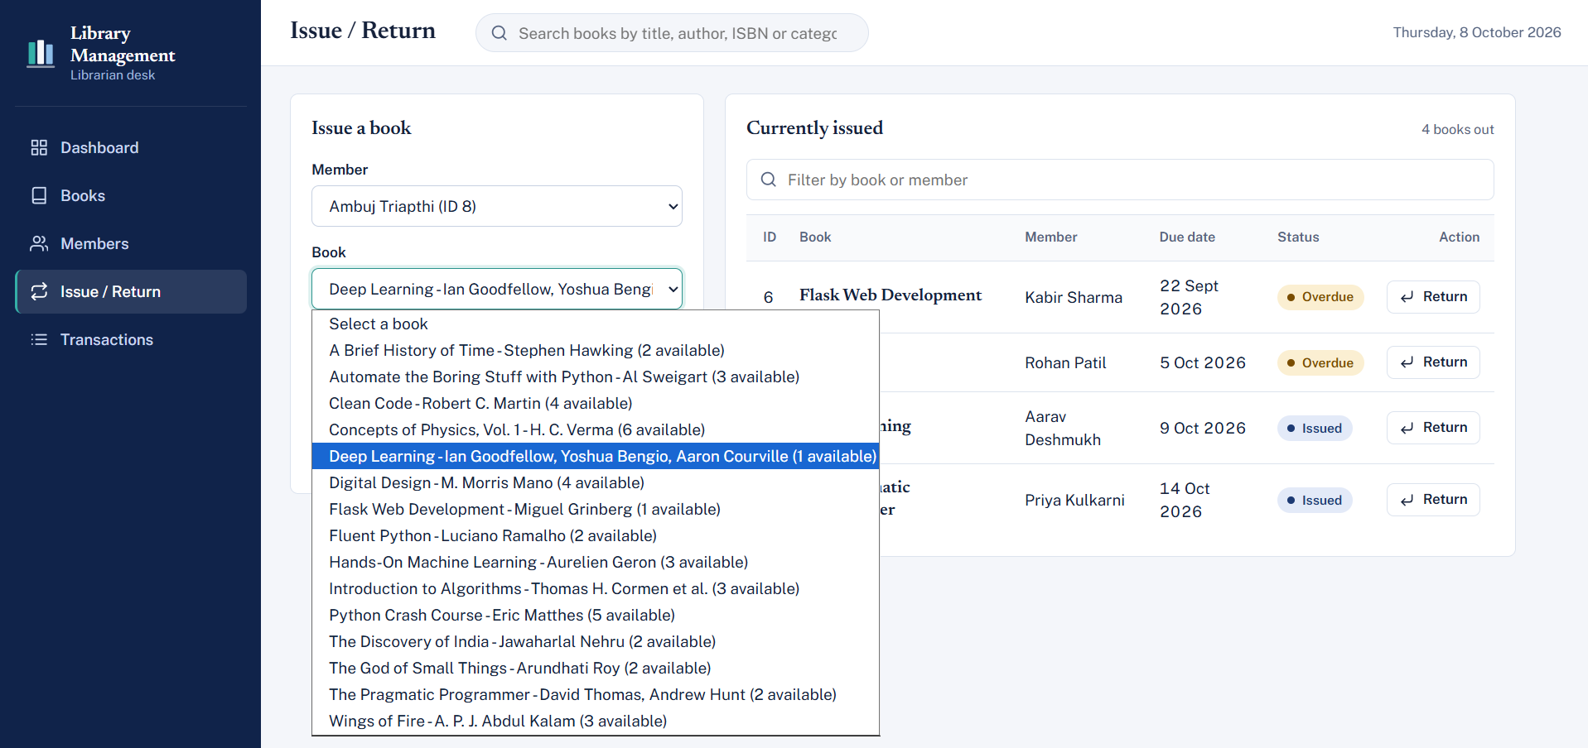
Figure 9: Selecting the book to issue; the list shows the number of available copies for each title.
The issue date defaults to today (08-10-2026) and the due date to 14 days later (22-10-2026). Both fields use a date picker, so the librarian can change them if needed.
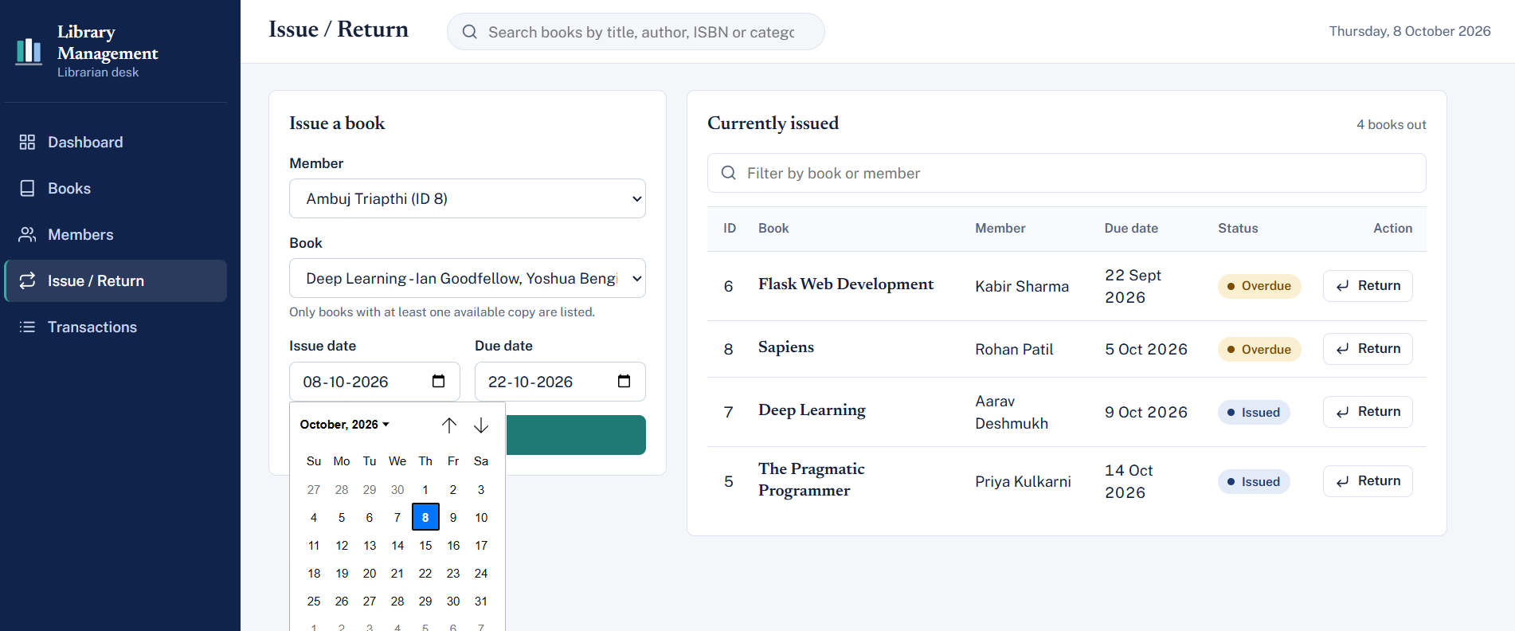
Figure 10: Issue date and due date fields with the date picker open.
Clicking Issue book completes the transaction. A green message confirms that 'Deep Learning' was issued to the member with the due date of 2026-10-22, a notification appears in the corner, and the Currently issued table now shows 5 books out, including the new entry with the status Issued.
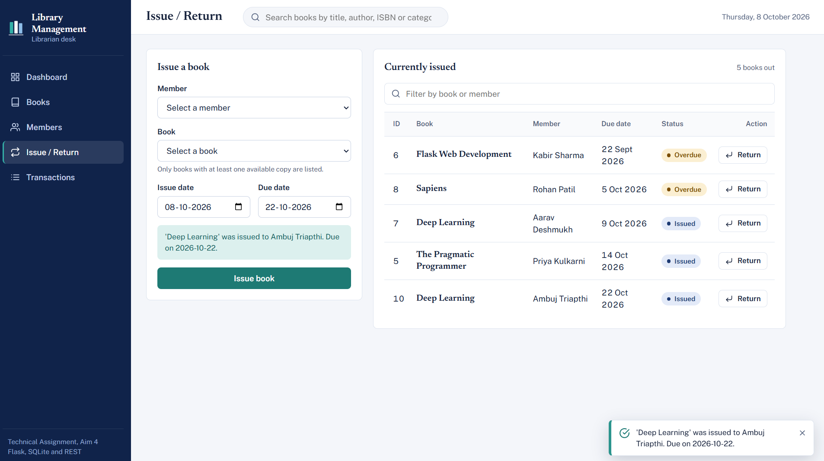
Figure 11: Confirmation after issuing a book; the Currently issued table now lists 5 books.

3.7 Transactions
The Transactions page records every issue and return. The tabs All, Active issues and Returned filter the list, and a search box finds entries by book, member or transaction ID. The All view shows 10 transactions recorded, each with issue date, due date, return date and status.
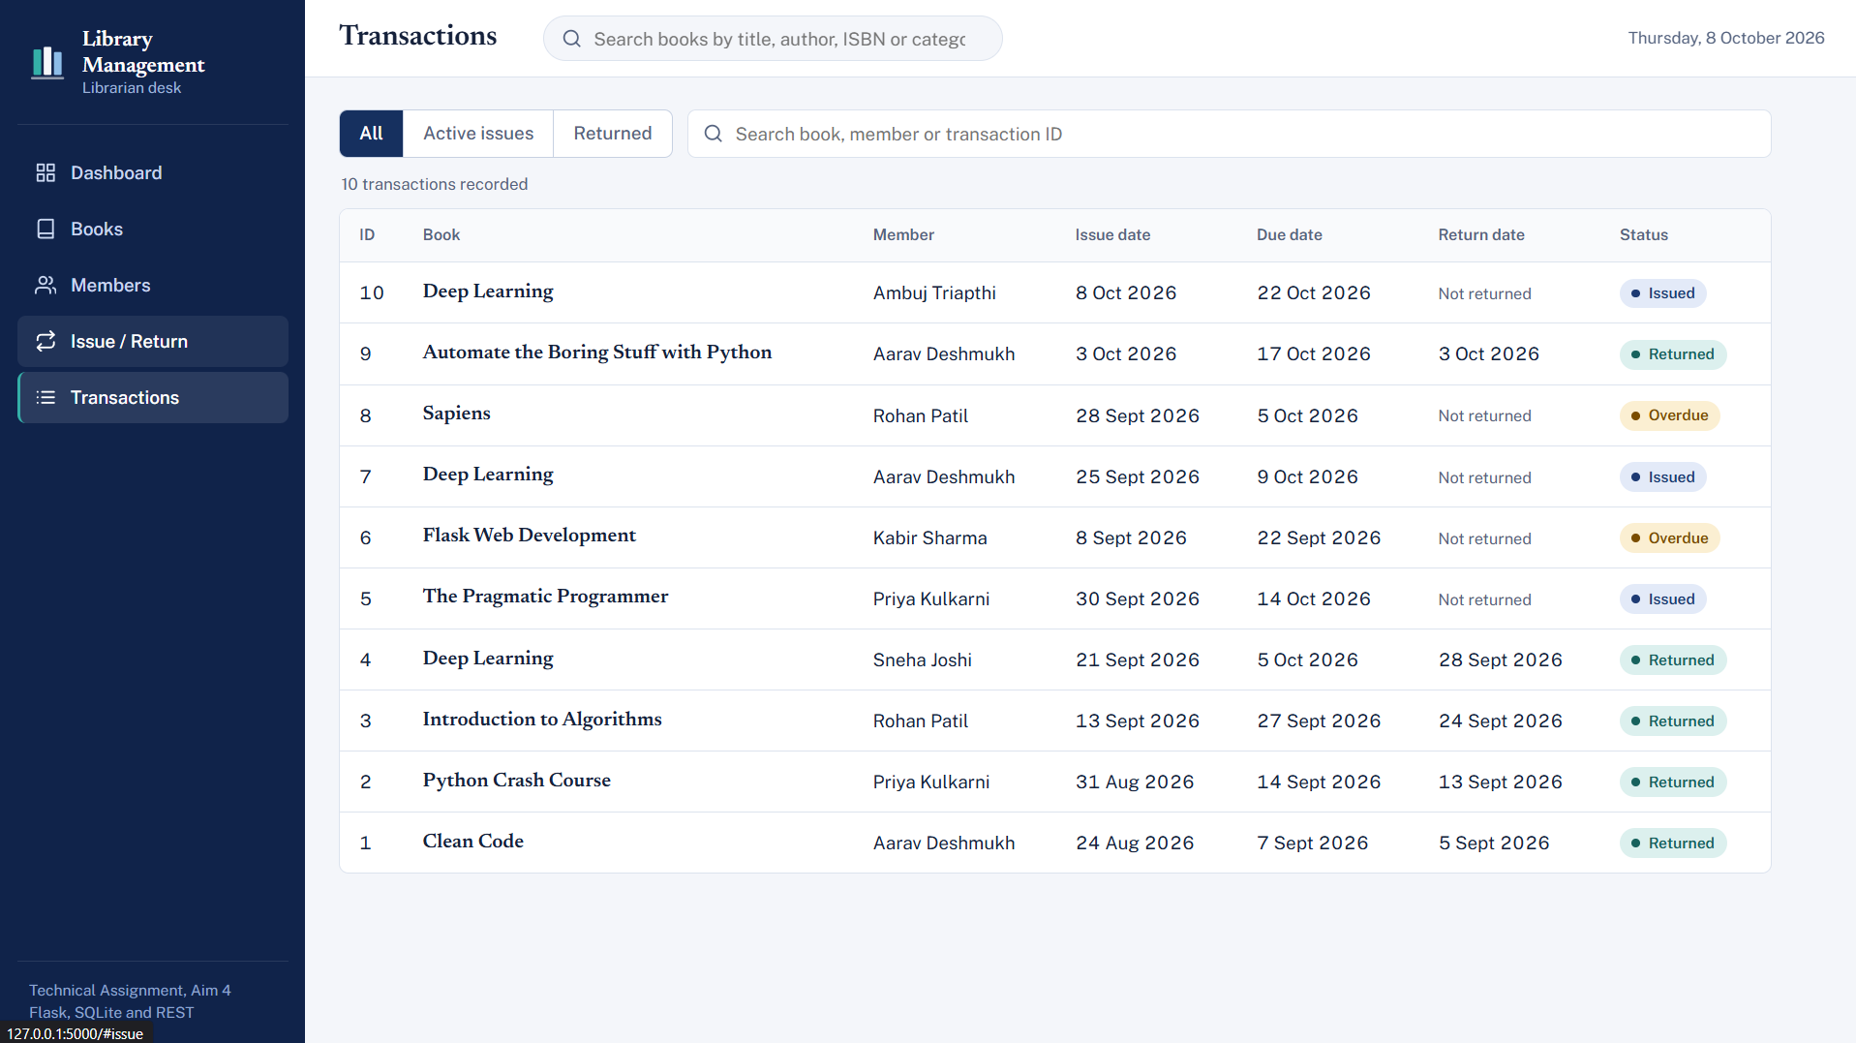
Figure 12: Transactions page, All tab: 10 transactions recorded with their statuses.
The Active issues tab shows only the 5 books that have not yet been returned. Two of them (Sapiens and Flask Web Development) are marked Overdue because their due dates have passed, while the others are marked Issued.
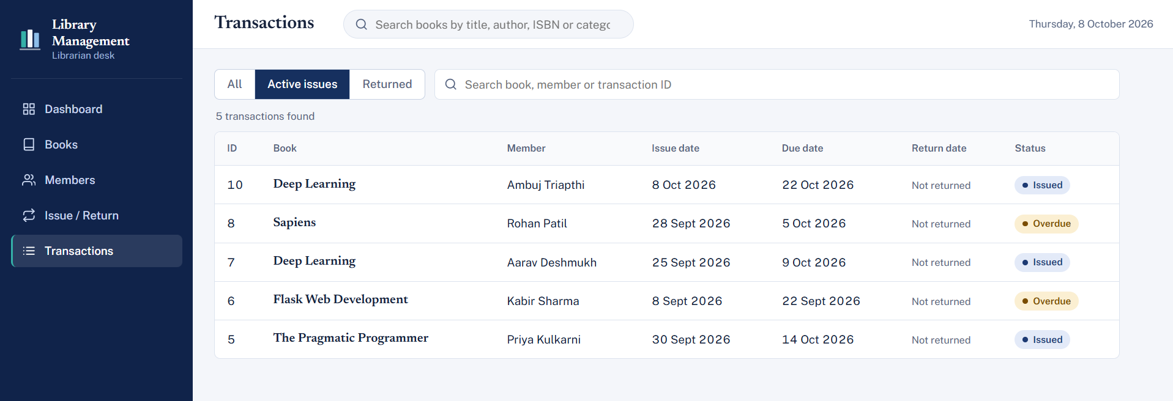
Figure 13: Transactions page, Active issues tab: books not yet returned, with Overdue and Issued statuses.

4. Conclusion
The Library Management System covers the main day-to-day tasks of a library desk: maintaining the catalogue, registering members, issuing and returning books, and tracking overdue items. Flask serves both the interface and the REST API, SQLite keeps the data in a single file, and input validation protects the database from bad entries. The screenshots above demonstrate each module working end to end, from adding a member to issuing a book and seeing it appear in the transaction history.

